APTECH SHAHRAH E FAISAL

Team: PharmaCoders

Miss Syeda Laiba

FACULTY

|  |  |  |  |
| --- | --- | --- | --- |
| Abdul Rehman  ID: 1537104 | | Jawad Ul Bahar  ID: 1551146 | |
| Abdul Samad  ID: 1544936 | | Aiman Ishaq Roy  ID: 1545719 | |
| Areeba  ID: 1546355 | |

Our Team

Introduction

Online Pharmacy

**Overview**

The pharmaceutical industry is one of the most research-intensive sectors globally, requiring precision, quality, and trust. **XYZ Pharmaceuticals**, a company engaged in the production and distribution of pharmaceutical equipment such as Capsule/Encapsulation machines, Tablet processing units, Liquid Filling systems, and other related tools, has identified the need to expand its digital presence.

To meet modern market demands and reach a wider audience, the company has proposed the development of a professional and fully-featured web application titled **Online Pharmacy**. This application aims to provide users with comprehensive access to product details, manufacturing processes, quotation requesting, and career opportunities, all while improving customer engagement and branding.

**Objective of the Project:**

The **Online Pharmacy** system is being developed to:

* Promote and advertise the company's products and services online
* Offer detailed descriptions and dimensions of pharmaceutical processes and machinery
* Allow potential job candidates to apply online through a **Career** section
* Enable users to send feedback, inquiries, or quote requests through a **User Quote** form
* Provide an admin-controlled backend for content and data management

Project Requirement:

* Home Page

The **Home Page** is the main entry point of the Online Pharmacy website. It gives a quick introduction to the company and shows all the important links that users can access.

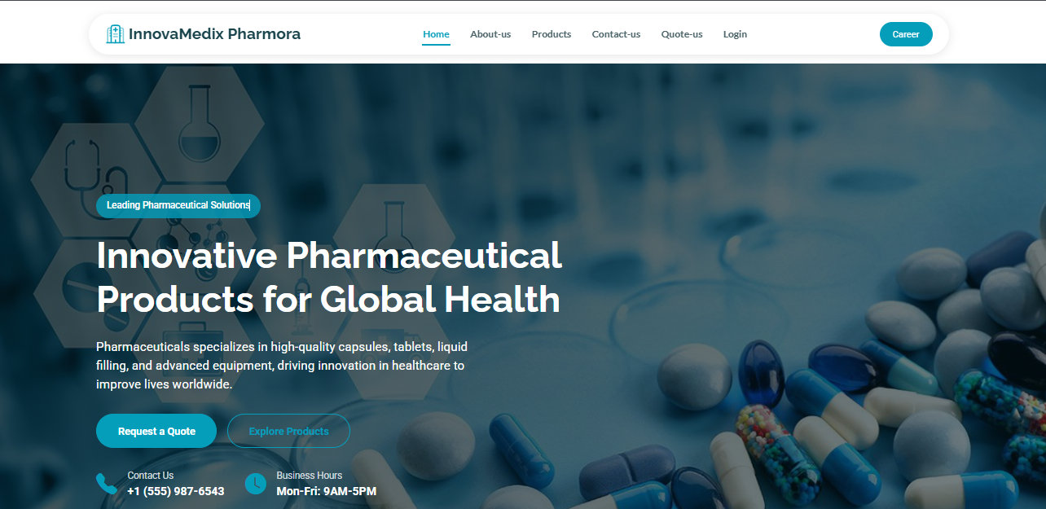

Source Code:

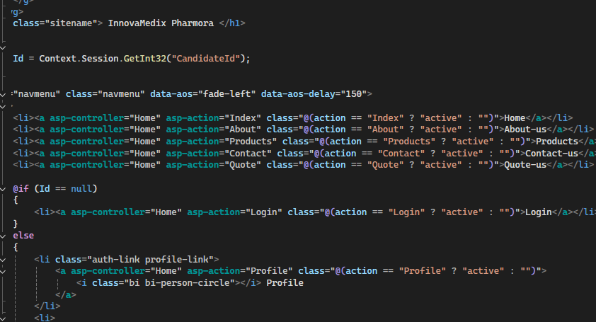

Overview:

At the top of the page, there is a **navigation menu** that includes the following links:

* **Home** – Brings users back to the main page
* **About Us** – Provides detailed information about the company
* **Products** – Displays all product categories and details
* **Contact Us** – Allows users to send messages or inquiries
* **Careers** – A page for job seekers to apply online and upload their resumes
* **Quote** – A form where users can give feedback or request specific product information
* **Admin Login** – For authorized staff to log in and manage the website

Products:

We offer a wide range of pharmaceutical manufacturing solutions including Capsule Encapsulation, Tablet Manufacturing, and Liquid Filling. Each category features high-efficiency machines with detailed specifications to meet industry demands.

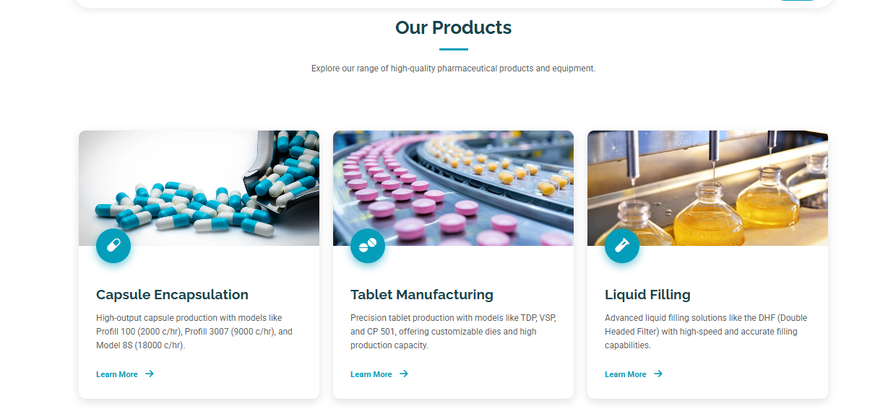

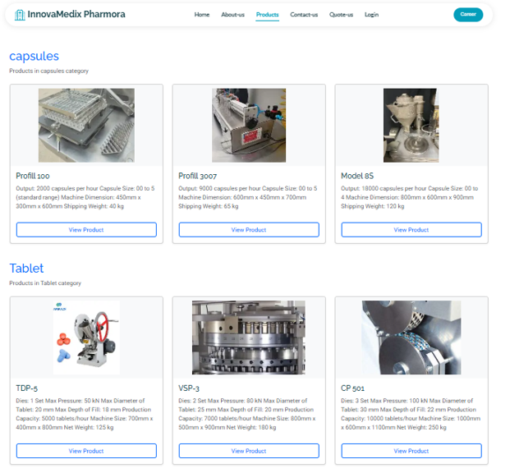

This section displays a table of all pharmaceutical products, showing their model name, detailed description, image, and category (such as Capsules or Tablets). Admins can easily **Edit**, **View Details**, or **Delete** each product directly from this panel.

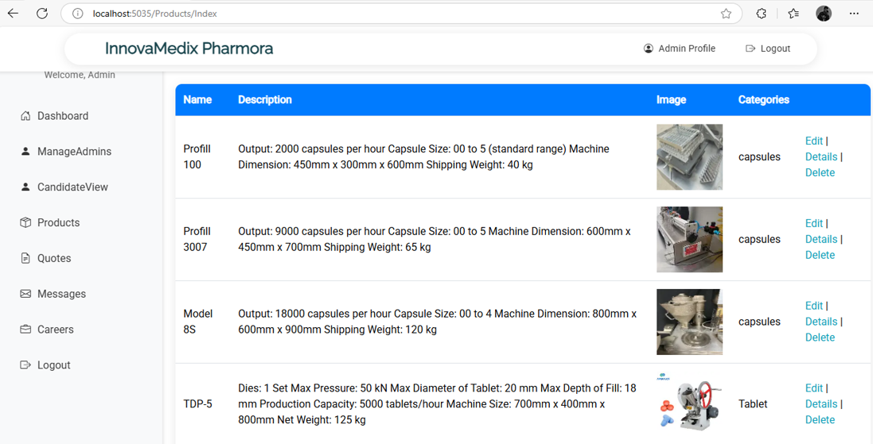

Career Form:

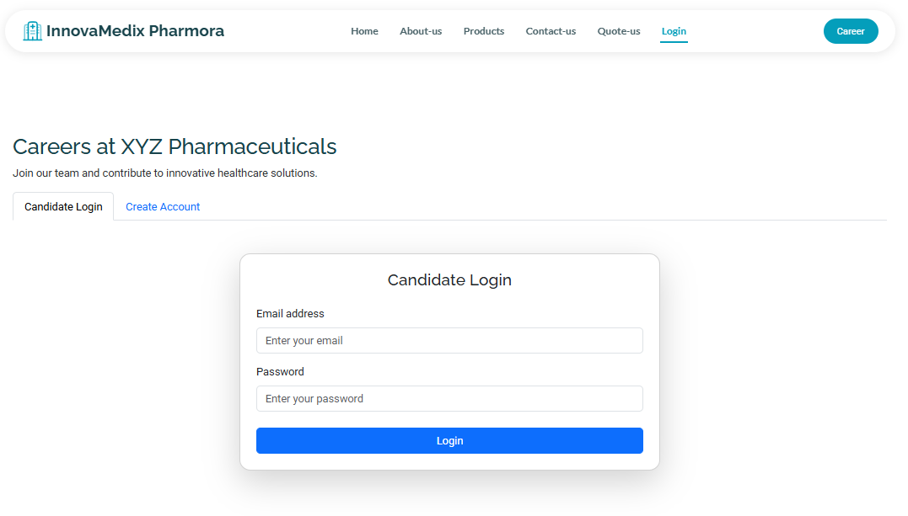

Users can apply for jobs by filling out their **personal, educational, and professional details** and uploading their **resume**. The form ensures secure account creation with email and password for future access.

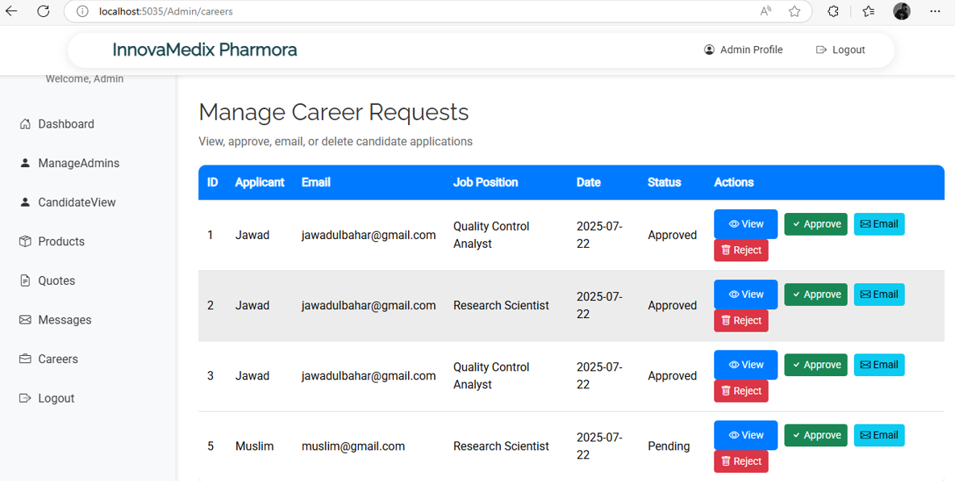

This section allows the admin to **view**, **approve**, **reject**, or **email** job applicants. All career requests are displayed with their details, job roles, status, and actions for easy hiring decisions.

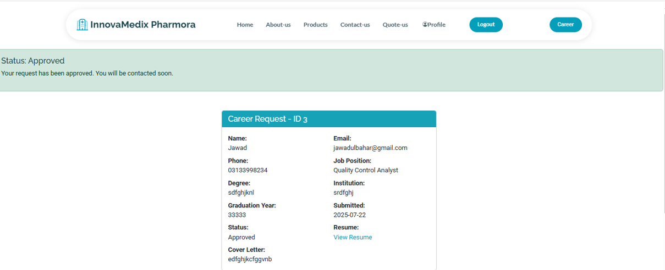

.

Admin Dashboard

Admin Panel:

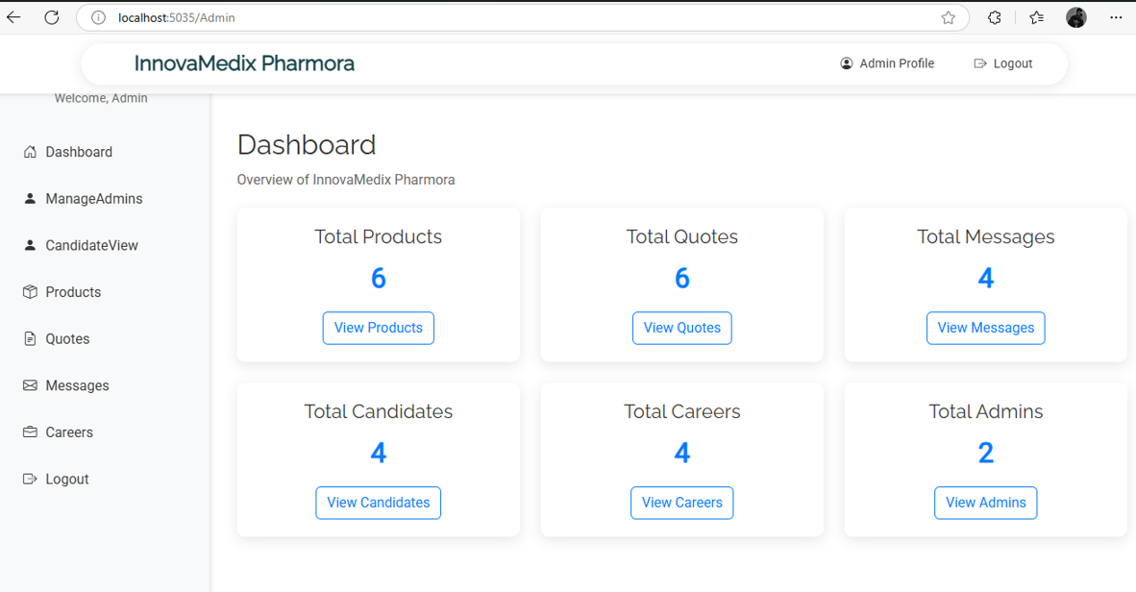

This panel allows the administrator to manage products, candidates, quotes, messages, and career requests efficiently through a user-friendly side menu.

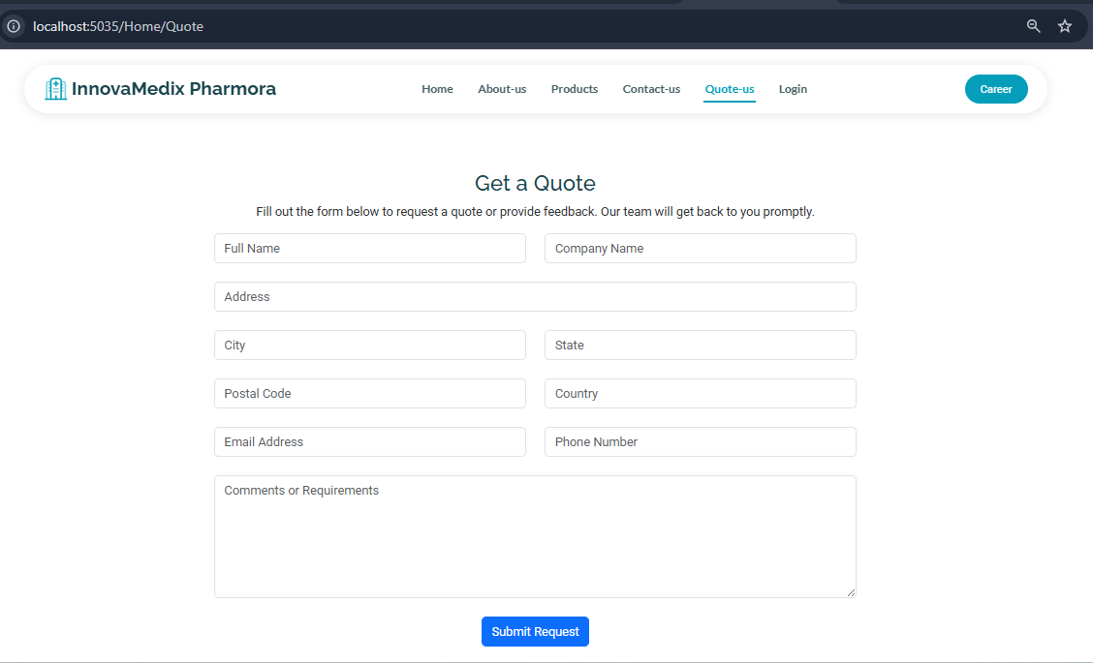Quote Form:

This section allows users to submit inquiries or request quotations by providing their contact and company details along with comments

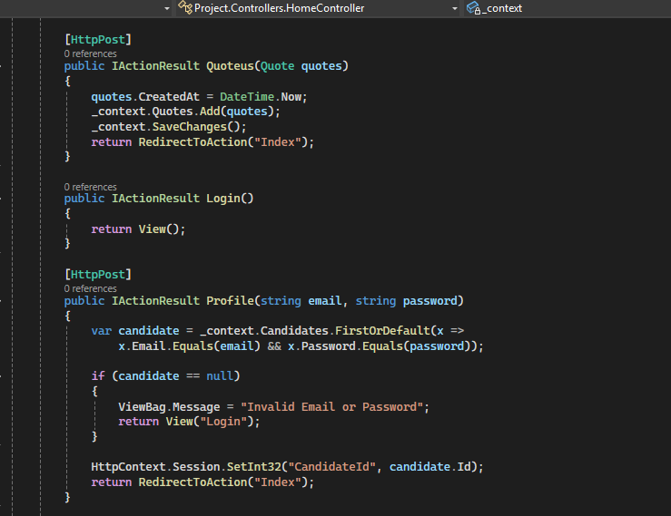 Source Code:

Contact us Form:

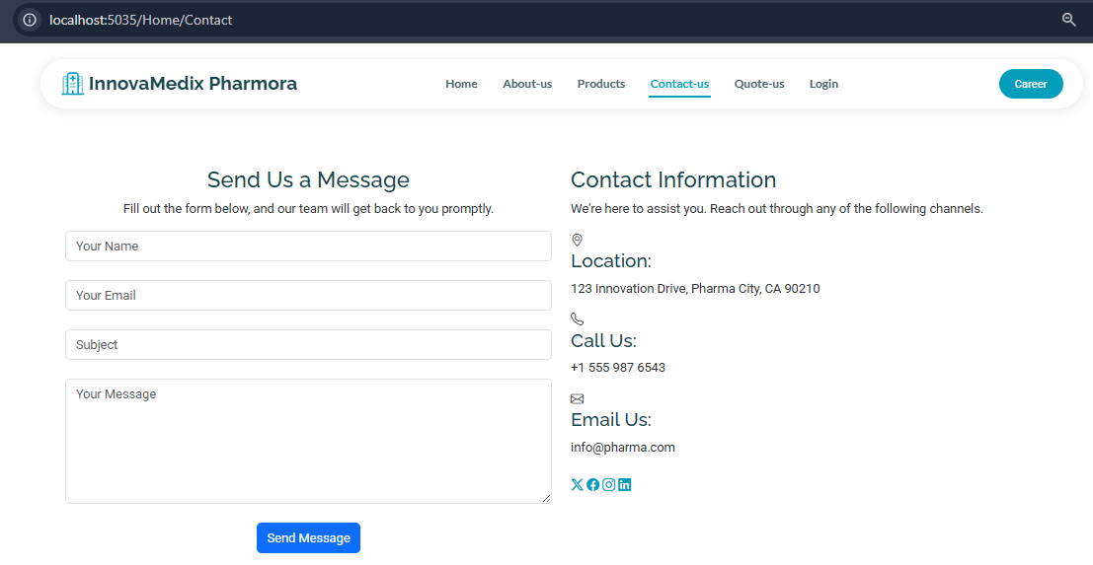

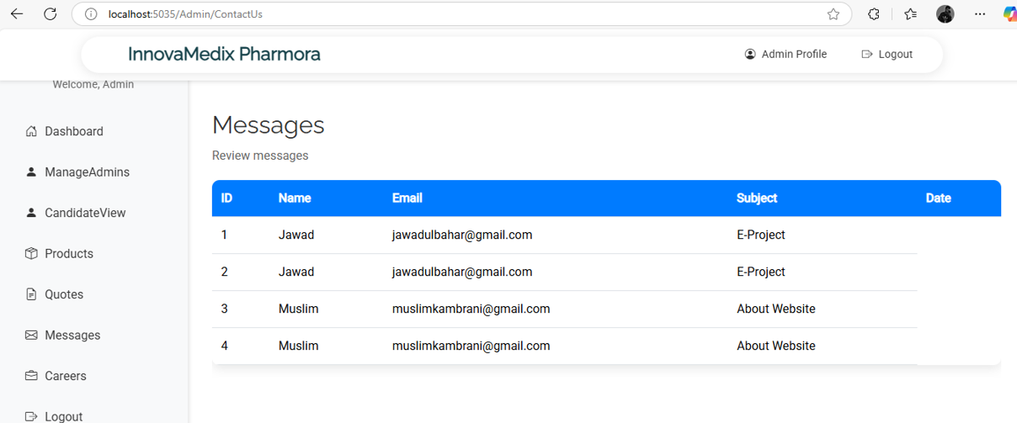This page enables users to reach out to the company by submitting their name, email, and message for support or general inquiries.

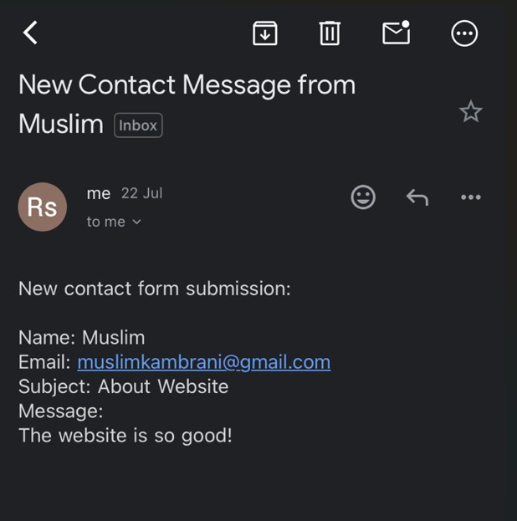

Sent email from Panel:

**Automated Email Response**  
When a customer submits a query or quote, they receive a default confirmation email from the admin side, acknowledging receipt of their message and ensuring prompt follow-up.

Interview Call email:

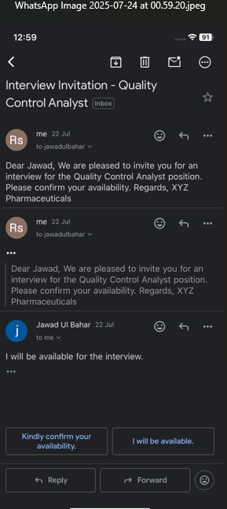

Overview:

This feature allows users get default set email from Admin on submission of his expected required cv.